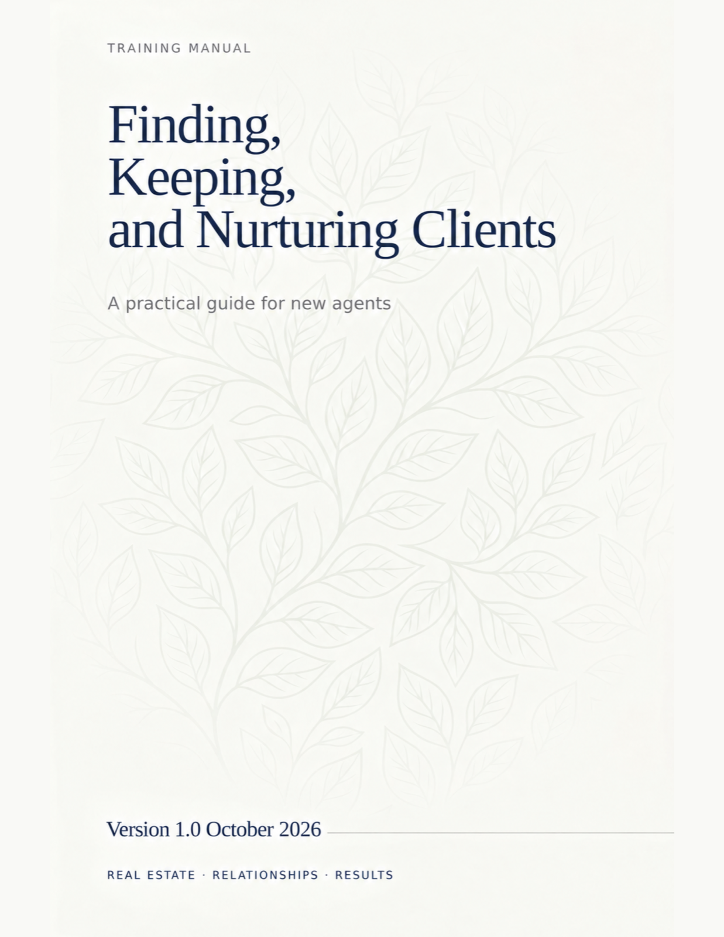

How to use this handbook
Most new agents do not fail for lack of effort. They fail because effort is scattered across activities that do not compound. This handbook gives you one system with three outcomes, and every chapter serves one of them.
- Find. Generate a steady flow of conversations with people who may buy or sell.
- Nurture. Follow up often enough, and helpfully enough, that you are the agent they call when they are ready.
- Keep. Stay useful after closing so past clients send you the next ones.
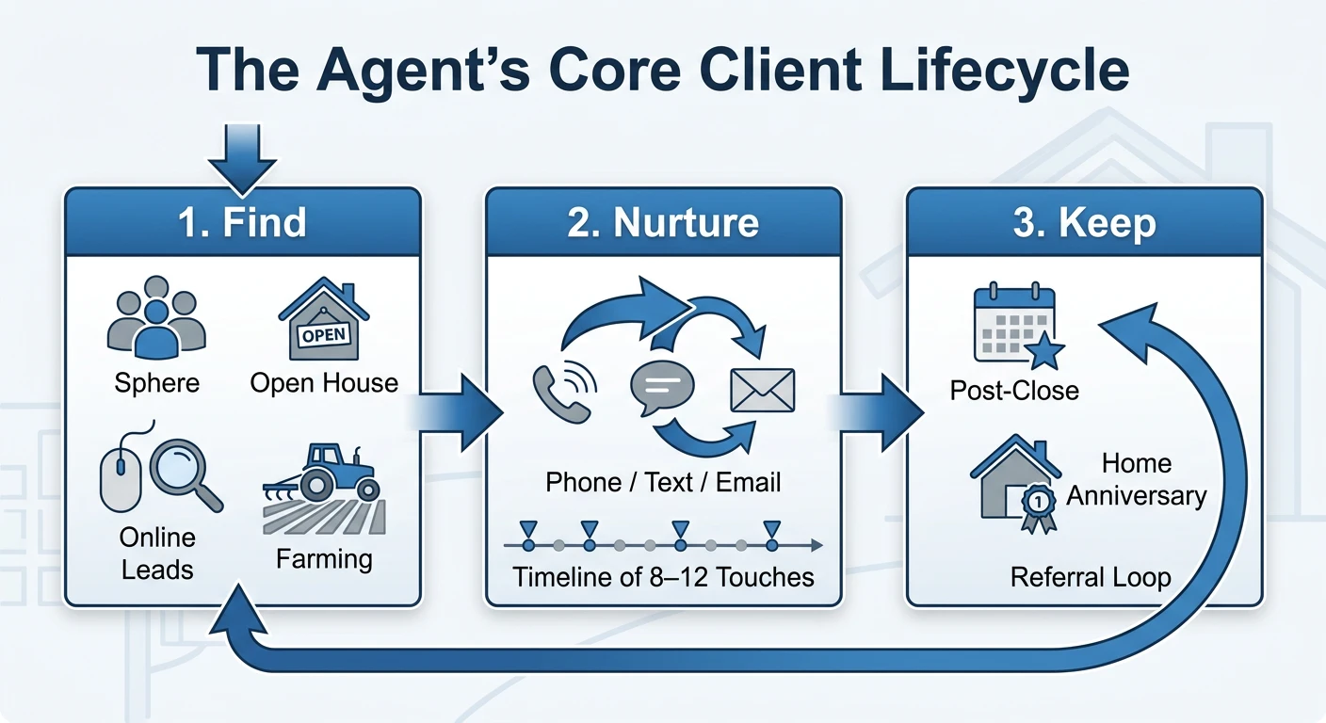
Figure 1. The core client lifecycle. Every activity in this handbook belongs to one of the three stages, and the referral loop turns Keep back into Find.
The book is written to be worked, not just read. Each chapter opens with what you will be able to do by the end, teaches the idea, shows the words to say, and closes with an exercise and a checkpoint. Read a chapter, do the exercise the same day, and move on. Do not try to install everything in one weekend.

Reading plan
- Week 1: Chapters 1, 4 and 12. Set up your CRM, protect your calendar, and learn what you will measure.
- Week 2: Chapters 2, 5 and 6. Start conversations and put every lead on a plan.
- Week 3: Chapters 7, 8 and 9. Audit your habits and practice consultations.
- Week 4: Chapters 3, 10, 11 and 13. Add marketing, post-close plans and professional safeguards.

What the boxes mean
● FIELD NOTE | A practical tip from agents who do this every day.
● PITFALL | A trap new agents fall into, and how to avoid it.
● SCRIPT | Words to say. Personalize them, then practice out loud.
● TRY IT TODAY | An exercise you can finish in under an hour.
● CHECKPOINT | Questions to confirm you can apply the chapter.

Contents
How to use this handbook 1
Reading plan 1
What the boxes mean 2
Contents 3
Foundations 6
1 Mindset and business foundations 7
You own a business now 7
Leading and lagging indicators 7
Working backward from an income goal 8
Your CRM is your headquarters 9
Find 10
2 Finding clients 11
Sphere of influence and referrals 11
Online leads 12
Open houses 12
Geographic farming 13
Expired listings and for-sale-by-owners 13
Track every source 14
3 Marketing and brand presence 16
Your home base 16
A content calendar you can keep 16
Market every listing thoroughly 17
Paid advertising 17
Your operating system 19
4 Technology and systems 20
The one-time setup 20
The daily rhythm 21
Speed-to-lead 22
Optional tools 23
Nurture 25
5 Nurturing leads 26
Why one call is never enough 26
Designing a nurture plan 27
The follow-up plan starter library 28
Qualify early 29
The weekly pipeline review 29
6 Scripts: conversations that convert 31
How to use a script 31
Three rules for any script 33
Stay on track 35
7 Common errors and pitfalls of new agents 36
The six errors 36
How the errors feed each other 37
The one correction 37
8 Staying organized and motivated 39
One source of truth 39
A sample day 39
Time-blocking the week 40
Weekly activity targets 40
Motivation that lasts 41
Serve and keep 43
9 Working with clients and dealing with objections 44
The consultation sequence 44
Objections are questions in disguise 45
Objection quick reference 45
Document everything 47
After the transaction 47
10 Keeping clients: long-term relationships 49
The post-close plan 49
Adding value without selling 50
Reactivating a quiet database 50
11 Legal protection and professional standards 52
Agency disclosure 52
Fair Housing 52
What to document 53
Professional standards 53
Execute 55
12 Daily, weekly and monthly execution plans 56
Days 1 to 30: install the system 56
Days 31 to 60: build the rhythm 57
Days 61 to 90: grow the pipeline 57
Measure every week 57
Review every month 57
13 Resources and next steps 59
Do these this week 59
Where to get help 59
The two habits that matter most 59
Tools to print and use 61
A Weekly activity scorecard 62
B Follow-up plan starter kit 64
B.1 New online lead (90 days) 64
B.2 New sphere contact: 8x8 (8 weeks) 65
B.3 Quarterly database plan (ongoing) 65
B.4 Post-close plan (first year) 65
C CRM setup checklist 66
Profile 66
Contacts 66
Follow-up plans 66
Pipeline and routing 66
Mobile and testing 67
D Glossary 68

PART I

Foundations
Before tactics, the one decision that shapes everything else: you are running a business, and businesses run on systems and leading indicators.
CHAPTER 1

1 Mindset and business foundations
Real estate is a business, not a job. Your results come from the habits and systems you build, not from waiting for the phone to ring.
IN THIS CHAPTER YOU WILL LEARN TO
- Tell leading indicators from lagging indicators, and set goals on the right one.
- Work backward from an income goal to a daily number of conversations.
- Treat your CRM as your daily headquarters rather than an occasional tool.

You own a business now
When you were an employee, somebody else found the customers, set the schedule and decided what mattered. All three jobs are now yours. Nobody will assign you a task list on Monday morning, and no one will notice if you spend a week on busywork. That freedom is the reason most people enter the business and the reason most leave it.
The agents who last think of themselves as owners of a small company with one product: trusted guidance through a large financial decision. A company needs a way to find customers, a way to stay in touch with them, and a way to keep them. That is the whole structure of this book.

Leading and lagging indicators
A lagging indicator tells you what already happened. Closings, commission income and the number of listings you hold are all lagging. By the time they move, the work that moved them is weeks or months old.
A leading indicator is an activity you control today that predicts the lagging number later. Conversations held, appointments set, follow-up tasks completed and contacts added to your database are leading. You can do all of them tomorrow morning regardless of the market.
New agents who set goals only on closings get discouraged, because closings do not respond for 60 to 120 days. Set your goals on activity, review them weekly, and let the closings arrive on their own schedule.

Working backward from an income goal
Here is the arithmetic every agent should do once a year. Use your own local numbers; the ones below are an example.
STEP | EXAMPLE | YOUR NUMBER
Income goal for the year | $80,000
Average commission per closed side after splits | $6,500
Closings needed (goal ÷ average) | 13
Appointments needed per closing (new agents: about 3) | 39 appointments
Conversations needed per appointment (new agents: about 20, blended across sources) | ≈ 780 conversations
Working weeks | 48
Conversations per week | ≈ 16
Conversations per working day | 3 to 4

Table 1.1. The goal ladder. A conversation means a real two-way exchange about real estate with a person who could buy, sell or refer, not a voicemail.
Three or four real conversations a day feels small. That is the point. A daily target you can hit on a bad day is worth more than a heroic target you hit twice and abandon.
● FIELD NOTE
Your ratios will be worse than the example in your first six months and better after a year. Track your own. Once you know that you need eight conversations to book one appointment, your daily plan writes itself. Table 8.2 gives the full set of weekly targets for a new agent.

Your CRM is your headquarters
Your CRM is where your contacts, tasks, follow-up plans, Opportunities and marketing live. The habit that matters most in your first 90 days is simple: open your CRM first thing every morning and update it before you stop working. Contacts that live in your phone, sticky notes and inbox are contacts you will forget. Agents who treat your CRM as non-negotiable stay organized. Those who do not fall behind within a quarter and rarely recover the lost leads.
● TRY IT TODAY
- Fill in the "Your number" column of Table 1.1 with your own income goal and your office's average commission.
- Write your daily conversation target on a card and put it where you work.
- Block 9:00 to 11:00 tomorrow morning in your calendar and label it "Lead generation". Do not move it.

● CHECKPOINT
- Which three numbers will you track every week, and why are none of them closings?
- How many conversations do you need per week to reach your income goal?
- What is the first thing you will do in your CRM each morning?

KEY TAKEAWAYS
- Closings lag by two to four months. Measure the activity that produces them.
- Work backward from income to a daily conversation target you can hit on your worst day.
- Your CRM is the single source of truth. Open it first, update it last.
PART II

Find
Where clients come from, what each source costs, and how to make your name mean "local expert" before anyone needs you.
CHAPTER 2

2 Finding clients
Every lead source trades time for money or money for time. Know the trade you are making, track every source, and double down on what converts.
IN THIS CHAPTER YOU WILL LEARN TO
- Build and work a sphere of influence list without feeling like a salesperson.
- Compare lead sources by conversion rate, cost and exclusivity.
- Run an open house as a lead-generation event rather than a waiting room.
- Track cost per closed deal by source.

Sphere of influence and referrals
Your sphere of influence is everyone who already knows you and would take your call: family, friends, former colleagues, neighbors, your dentist, the parents at your kid's school, the people in your gym class. For most agents this is the highest-return source they will ever have, because trust is already built and the cost is only time.
Build the list first. Go through your phone contacts, social media connections, email history and holiday card list. Most people find 150 to 300 names. Import every one into your CRM and tag them by relationship so you can sort later.
Then work the list with value first. The order matters:
- Announce. Tell everyone you are in real estate and with whom. One message, personal, not a mass blast.
- Give. Send something useful: a neighborhood market update, a home maintenance checklist, an introduction to a good contractor.
- Ask. After two or three helpful touches, ask for introductions. Chapter 6 has the words.
- Repeat. Put the whole sphere on a touch plan so no one hears from you only when you want something.
● PITFALL
New agents often skip the sphere because calling friends feels awkward, then spend money on portal leads to avoid the discomfort. Your sphere converts at five to ten times the rate of a portal lead. The awkwardness fades after the tenth call. The ad bill does not.

Online leads
Portal leads (Zillow Premier Agent and similar), your own ads, and inquiries through your Agent Site or IDX website provide volume. They also convert at a far lower rate, because the person has no relationship with you and has often inquired with several agents at once. Two things decide whether online leads pay off:
- Speed. The first agent to make real contact usually wins the conversation. Chapter 4 covers the five-minute response window.
- Persistence. Most online leads are 6 to 18 months from a transaction. Without a long nurture plan you are paying to warm up a lead for someone else.
Do not rely on online leads exclusively, and do not buy them until your follow-up system is built and tested on your sphere. Chapter 3 says more about when paid lead generation makes sense.

Open houses
An open house is a lead-generation event with a listing as the excuse. Treat it that way and it will produce buyers who are active now and neighbors who may sell next year. Treat it as sitting in a house for three hours and it will produce nothing.

Before
- Preview the home and the five nearest comparable sales so you can answer price questions on the spot.
- Invite the 20 nearest neighbors in person or with a door-knock the day before. "Would you like to see what your neighbor's home is listed for?" is an easy opener.
- Set up digital sign-in on a tablet that feeds your CRM. Paper sign-in sheets get lost.

During
- Greet every visitor, ask one open question about their search, and capture name, phone and email.
- Ask the qualifying questions from Chapter 5 in conversation: timeline, area, financing, whether they are working with an agent.
- Offer a concrete next step: a list of similar homes, a buyer consultation, or a neighbor's home value report.

After
- Follow up with every visitor within 24 hours. A text the same evening and a call the next morning is the standard.
- Put every visitor on a follow-up plan. The visitor who was "just looking" today is often the buyer in four months.
- Log the open house and its visitors as a lead source so you can measure it.

Geographic farming
Farming means choosing one neighborhood of 300 to 500 homes and becoming the agent everyone there recognizes. It works through consistency: monthly mailers, door-knocking, a neighborhood market report, sponsoring the block party. Expect six to twelve months before listings appear. Pick a farm with a turnover rate of at least 6 percent a year, few dominant agents, and homes at a price point that pays you fairly for the effort.

Expired listings and for-sale-by-owners
Owners whose listing expired, or who are trying to sell alone, have already raised their hand. Many agents will call them, so the approach has to be respectful and persistent. Lead with curiosity about what they want to do next, not with criticism of their last agent or their price. This source rewards skilled, consistent prospectors and frustrates everyone else.
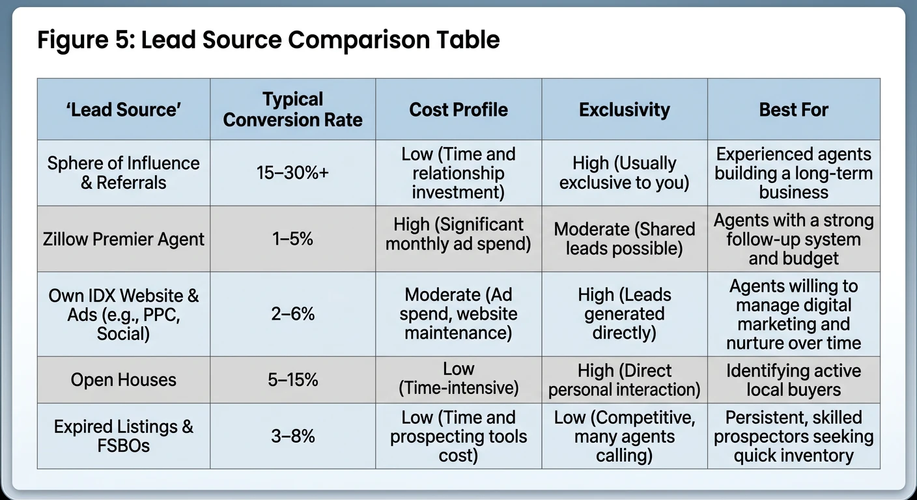
Figure 2. Lead source comparison. Conversion ranges are typical industry figures and vary by market and by how well you follow up. Use them to choose where to start, then replace them with your own numbers.

Track every source
In your CRM, every contact carries a lead source. Fill it in every time. At the end of each month, count by source: contacts added, appointments held, closings, and dollars spent. The number you want is cost per closed deal, which includes your time at a rate you choose. After six months you will know which sources deserve more of your week and which to stop.
● TRY IT TODAY
- Build your sphere list. Aim for 150 names. Import them into your CRM with a "Sphere" tag.
- Send the announcement message to the first 20 people. Personal, two sentences, no sales pitch.
- Ask a colleague whether you can host their next open house. Schedule it.

● CHECKPOINT
- Why do sphere contacts convert so much better than portal leads?
- What three things must be in place before you pay for online leads?
- What is your 24-hour follow-up standard after an open house?

KEY TAKEAWAYS
- Your sphere is the best-converting, cheapest source you will ever have. Work it first.
- Online leads need speed and a long nurture. Without both, you are paying to warm leads for other agents.
- Open houses are events: invite neighbors, capture digitally, follow up within 24 hours.
- Tag every contact with a source and measure cost per closed deal.
CHAPTER 3

3 Marketing and brand presence
Marketing should make people feel two things: you are the local expert, and you are the person who will take care of them. Consistency beats perfection.
IN THIS CHAPTER YOU WILL LEARN TO
- Set up a home base with your Agent Site and Client App.
- Keep a simple content calendar you can sustain for a year.
- Market a listing so it produces buyer and seller leads, not just a sale.
- Decide when paid advertising is worth it.

Your home base
Your Agent Site and Client App are the places you send everyone. The site holds your profile, your listings, and home search for your market. The app gives your clients a branded search experience that keeps you attached to every home they save. Set both up in your first week, with a professional photo, a short bio written in plain language, and your real contact details. Check that every link on your social profiles and email signature points to them.

A content calendar you can keep
People hire the agent they remember. Showing up regularly with useful information is how they remember you. Pick a schedule that you can keep on a busy week, then keep it. A workable minimum for a new agent:
CADENCE | CONTENT | WHERE
Weekly | One neighborhood or market observation: what sold, what is new, what surprised you. | Social post, email to sphere segment
Weekly | One educational tip: inspection, financing, timing, preparing a home. | Short video or image post
Monthly | Market update with three numbers: median price, days on market, months of inventory. | Email newsletter via your CRM, mailer to farm
Quarterly | A local guide: schools, parks, restaurants, events. | Blog post on Agent Site, shareable PDF
Per listing | Coming soon, just listed, open house, under contract, just sold. | Social, email, mailers to the neighborhood

Table 3.1. A minimum sustainable content calendar. Batch-create a month of posts in one sitting.
● FIELD NOTE
You do not need to be a video personality. A 45-second phone video of you standing in front of a sold home, explaining one thing the buyer learned, outperforms a polished stock graphic. People hire people.

Market every listing thoroughly
A listing is the most powerful marketing asset you will hold. Good listing marketing sells the house and also generates buyers (who call about it) and sellers (neighbors who see you working). For every listing, at minimum:
- Professional photography and a floor plan. Phone photos cost sellers money and cost you credibility.
- A "coming soon" post and a "just listed" post, each with a call to action that leads to you.
- Mailers or door-knocks to the 50 nearest homes before the open house.
- A "just sold" update with a line about how many showings or offers it received. This is the single best seller-lead post you can make.

Paid advertising
Facebook and Instagram ads, Google ads and portal placements can all accelerate volume. They are worth it only when your follow-up system is already catching and nurturing leads reliably. The test is simple: if a new lead arrived at 9 p.m. tonight, would they get an immediate automated reply, a call before 9 a.m., and a 90-day plan without you having to remember? If not, buying leads is buying a leak.
When you do start, start small, run one source at a time for 90 days, and track cost per appointment and cost per closed deal before scaling.
● PITFALL
Spending on branding before spending time on conversations. Logos, car magnets and a custom website produce nothing on their own. Your first marketing budget is your calendar.

● TRY IT TODAY
- Complete your Agent Site profile and send yourself the Client App invitation to see what a client sees.
- Record one 45-second video answering the question you were asked most often this week.
- Write next month's four weekly posts in one sitting and schedule them.

● CHECKPOINT
- What two feelings should your marketing create, and which of your current posts create them?
- Name the five posts every listing should generate.
- What must be true before you buy leads?

KEY TAKEAWAYS
- Agent Site and Client App are the home base. Send everyone there.
- A modest, consistent content schedule beats bursts of brilliance.
- Every listing should produce buyers and future sellers, not only a closing.
- Paid ads amplify a system. They cannot replace one.
PART III

Your operating system
One tool, set up once, used every day. Your CRM is where the system lives, and speed-to-lead is its first rule.
CHAPTER 4

4 Technology and systems
Your CRM is your core tool. Set it up properly once so it works for you every day, then let it enforce the habits you have not built yet.
IN THIS CHAPTER YOU WILL LEARN TO
- Complete the six-part CRM setup in your first week.
- Run a CRM-centered daily rhythm.
- Configure speed-to-lead so a new inquiry gets a reply in minutes, even when you are busy.
- Decide when optional tools are worth adding.

The one-time setup
Your CRM rewards agents who set it up completely and punishes those who set it up halfway. Do these six things in order during your first week. Appendix C turns them into a checklist.
- Complete your profile and Marketing Profile. Photo, bio, phone, email, license number, social links, brand colors. Everything your CRM generates for you pulls from here.
- Import contacts. Phone, email, social and any spreadsheet you have. Deduplicate, then tag each contact by relationship (sphere, past client, lead) and by source.
- Create or download follow-up plans. Start with an 8x8 for new sphere contacts, a quarterly call plan for the whole database, a new-lead plan with fast early touches, and a post-close plan. Table 5.1 lists the starter library and Appendix B has day-by-day versions.
- Set lead routing rules if you are on a team, so inquiries reach the right person instantly.
- Customize your Opportunities pipeline. Rename stages to match how you actually work (for example: New, Contacted, Appointment set, Active, Under contract, Closed) so your pipeline view is honest.
- Install the CRM mobile app and turn on notifications for new leads and due tasks.

The daily rhythm
Once your CRM is set up, your day has a shape. Start in your CRM, work the follow-ups it hands you, prospect, hold appointments, and end in your CRM. The order matters: follow-ups come before prospecting because a lead you already have is worth more than one you have not met yet.
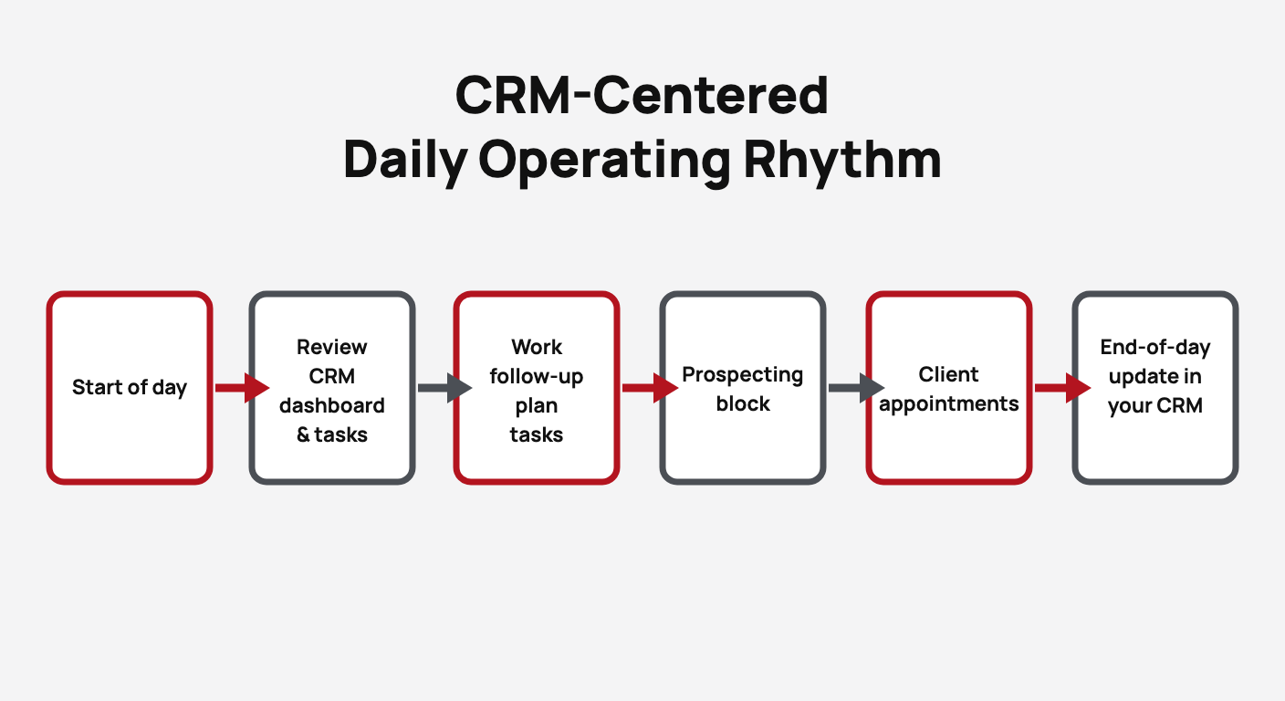
Figure 3. The CRM-centered daily operating rhythm. The day opens and closes in your CRM, and follow-ups come before new prospecting.
BLOCK | WHAT HAPPENS | TIME
Start of day | Review the dashboard: new leads overnight, tasks due today, Opportunities that moved. | 15 min
Follow-up plan tasks | Clear every due task: calls, texts, emails. Log the outcome on each contact. | 45 to 60 min
Prospecting block | New conversations: sphere calls, open house follow-ups, farm, expireds. Hit your daily number. | 60 to 90 min
Client appointments | Consultations, showings, listing presentations, inspections. | As scheduled
End of day | Log every conversation, move Opportunities to the right stage, set tomorrow's top three. | 15 min

Table 4.1. Time budget for the daily rhythm. Protect the first three blocks before you accept any appointment.

Speed-to-lead
When someone inquires online, they are usually sitting in front of a screen at that moment, and they have probably sent the same inquiry to two or three other agents. The agent who responds first with a real, human message is the one who gets the conversation. Response time is the single biggest factor you control in online-lead conversion.
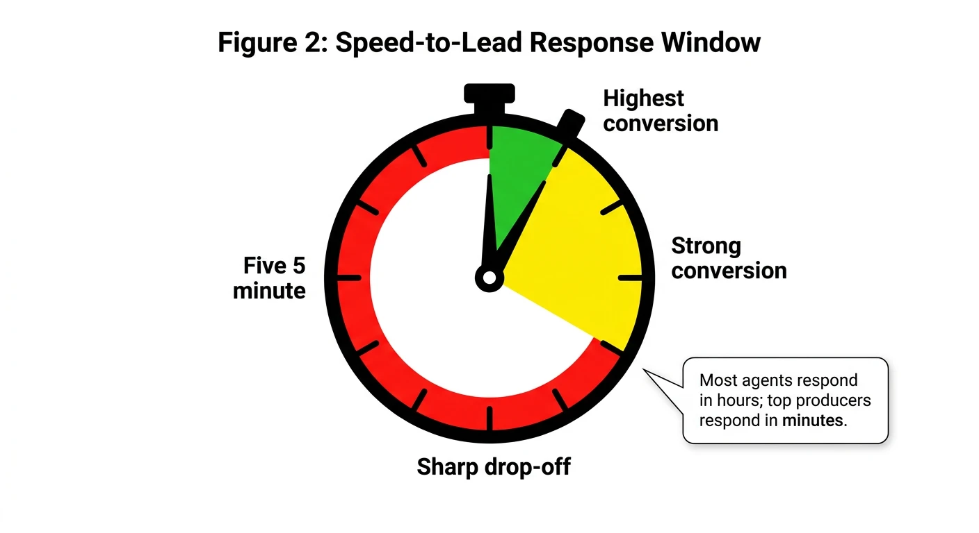
Figure 4. The speed-to-lead response window. Conversion is highest inside five minutes, still strong within about half an hour, and falls sharply after that. Most agents respond in hours. Top producers respond in minutes.
The standard is two layers:
- Automated first touch, within one minute. A new-lead follow-up plan sends a text and an email the moment the lead lands. It should sound like you and ask one easy question.
- Live call, within five minutes when possible, and always the same day. Turn on mobile notifications for new leads and step out of whatever you are doing. If you are with a client, let the automated text buy you time and call at the first break.
If you cannot make a live call within the hour, send a personal voice note or a short text that names the property or area they asked about. Specificity proves a human read the inquiry.
● FIELD NOTE
Test your own speed-to-lead. Have a friend submit an inquiry on your Agent Site at 8 p.m. on a weekday. Time how long until they get a text, an email and a call. Fix whatever is slower than you expected before you spend a dollar on ads.

Optional tools
Follow Up Boss, branded client apps, AI texting assistants and dialers can all add value later. Add them only when two things are true: your basic CRM system is running cleanly, and you have enough lead volume that the tool pays for itself. A new agent with a working CRM setup and 30 leads a month does not need a second CRM. A tool you have not mastered is one more place for a lead to get lost.
● TRY IT TODAY
- Work through Appendix C and finish the CRM setup checklist.
- Build the new-lead follow-up plan with an automated text and email on day 0, then run the speed-to-lead test above.
- Put the daily rhythm from Table 4.1 into your calendar as recurring blocks.

● CHECKPOINT
- What are the six parts of the CRM setup?
- Why do follow-up plan tasks come before prospecting in the daily rhythm?
- What two layers make up a speed-to-lead response, and how fast is each?

KEY TAKEAWAYS
- Set your CRM up completely in week one: profile, contacts, follow-up plans, routing, pipeline, mobile app.
- Open and close every day in your CRM. Follow-ups before prospecting.
- Speed-to-lead means an automated reply in a minute and a live call in minutes, not hours.
- Add optional tools only when the basics are working and the volume justifies the cost.
PART IV

Nurture
Most leads convert between the fifth and twelfth touch. Most agents quit after the second. The gap between those two facts is where your business is.
CHAPTER 5

5 Nurturing leads
Most leads do not convert on first contact. Follow-up that is frequent, varied and genuinely useful is what turns an inquiry into a client.
IN THIS CHAPTER YOU WILL LEARN TO
- Explain why multi-touch follow-up works and plan 8 to 12 touches over 90 days.
- Build follow-up plans that mix calls, texts, emails and value pieces.
- Qualify a lead early with four questions.
- Run a weekly pipeline review so nobody falls through the cracks.

Why one call is never enough
A person who inquires about a home online is usually months from a decision. They are curious, early, unsure of financing, or waiting on a life event. One call cannot carry them through all of that. Industry follow-up data consistently shows that the majority of conversions happen between the fifth and twelfth contact, spread across weeks or months. Most new agents stop after one or two attempts. The leads they abandon are the ones that would have closed for the agent who kept going.
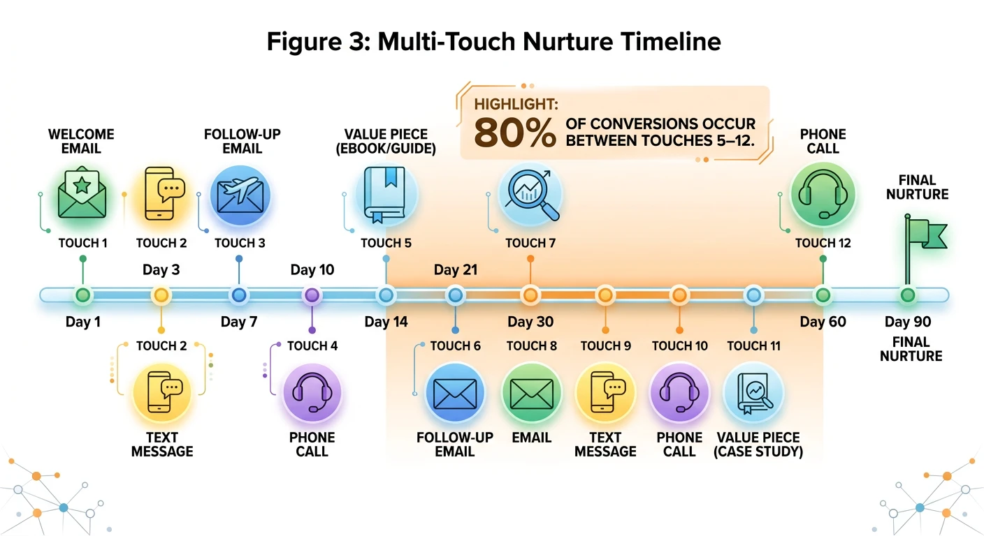
Figure 5. A multi-touch nurture timeline. Touches are front-loaded in the first two weeks, then spaced out, and every third or fourth touch gives something of value instead of asking for something.

Designing a nurture plan
A good plan has four properties. Build every follow-up plan against them.
- Front-loaded. Four or five touches in the first two weeks, while interest is highest.
- Mixed channel. Calls, texts and emails in rotation. Some people only answer texts. Some only read email. A single channel reaches a third of your list.
- Value every third touch. A neighborhood report, a buyer guide, a "homes like the one you asked about" list, a short video. Give before you ask.
- Long. At least 90 days of scheduled touches, then roll into the quarterly database plan. Nobody leaves your database unless they ask to.
Launch the right plan on every new lead the day it arrives, and launch the quarterly plan on your existing database this week. Table 5.1 shows which plan fits which contact, and Appendix B has day-by-day versions you can build into your CRM in an afternoon.
● FIELD NOTE
Write your automated texts the way you would type them to a friend. "Hi Jordan, it's Sam with [Brokerage]. Still thinking about the Maple Street area?" outperforms anything that sounds like a newsletter.

The follow-up plan starter library
Your CRM's library already contains plans for most of these. Start with three: the 8x8, the Quarterly Call Plan and New Lead Instant Response. Between them they cover the highest-impact activities. Add the neighborhood and long-term nurture plans once the first three are running consistently.
PLAN | PURPOSE | TOUCHES | BEST USE CASE | TIMING
8x8 New Contact | Rapid early engagement | 8 | Brand-new leads and fresh sphere contacts | First 8 days
Quarterly Call Plan (QCP) | Stay top of mind with the database | 4 per year | Sphere, past clients and long-term nurture | Every 90 days
Monthly Neighborhood Nurture | Local market value and visibility | 12 per year | Geographic farm and neighborhood presence | Monthly
New Lead Instant Response | Speed-to-lead automation | 3 to 5 | Portal, website and ad inquiries | Immediate, then first 7 days
Buyer Long-Term Nurture | Educate and stay in touch | 10 to 14 | Buyers not ready to move soon | Over 90 to 180 days
Seller Long-Term Nurture | Build the listing pipeline | 8 to 12 | Potential sellers and home valuation leads | Over 6 to 12 months
Home Anniversary | Post-close relationship maintenance | 1 to 2 per year | Past clients | On the purchase anniversary
Post-Close Thank You | Reinforce the relationship | 4 to 6 | Recently closed clients | First 60 to 90 days after close

Table 5.1. Follow-up plan starter library. Touch counts are approximate. The eight-day 8x8 above is the compressed version for leads whose interest is highest right now; the follow-up plan library also runs an eight-week 8x8 for sphere contacts, which Appendix B.2 lays out.
- Customize the language so it sounds like you. Library plans are starting points, not final scripts.
- Launch a plan on the contact in your CRM the day the contact arrives, then review and clear the resulting tasks daily.
- Chain plans: Instant Response rolls into a long-term nurture, which rolls into the Quarterly Call Plan. Nobody leaves the database unless they ask to.

Qualify early
Qualifying is not interrogating. It is asking the four questions that tell you how to help and how to prioritize your time. Work them naturally into your first real conversation.
QUESTION | WHAT YOU ARE LEARNING | NATURAL PHRASING
Timeline | When they want to move, and what is driving the date. | "When are you hoping to be settled in?"
Motivation | Why now, and how committed they are. | "What's prompting the move?"
Financing | Whether they are pre-approved, cash, or need a lender introduction. | "Have you had a chance to talk with a lender yet?"
Representation | Whether another agent is already helping them. | "Are you working with anyone on this yet?"

Table 5.2. The four qualifying questions. Record the answers in your CRM on the contact the same day.
Use the answers to place every lead in an Opportunity stage. A pre-approved buyer moving in 60 days is an active opportunity and gets calls. A "maybe next year" lead is a nurture and gets the follow-up plan. Both are valuable. They just need different attention this week.

The weekly pipeline review
Every Friday, open your Opportunities pipeline and your follow-up plan task list and ask three questions about every active contact:
- When did I last have a real two-way conversation with this person?
- What is the next step, and is it scheduled?
- Is this person in the right stage?
Anyone with no conversation in 14 days and no scheduled next step gets a call on Monday. This 30-minute habit is the difference between a pipeline and a list of names.
● PITFALL
Treating "no answer" as "not interested". Unanswered calls are normal. A lead who has not replied to three touches is still a lead. The plan continues until they say stop or until they buy.

● TRY IT TODAY
- Build the new-lead follow-up plan from Appendix B in your CRM and apply it to every lead from the last 30 days.
- Call the five oldest leads in your database that never got a plan. Ask the four qualifying questions.
- Put a recurring 30-minute "Pipeline review" block on Friday afternoons.

● CHECKPOINT
- What four properties should every nurture plan have?
- What are the four qualifying questions, in your own words?
- What triggers a Monday call during your Friday pipeline review?

KEY TAKEAWAYS
- Most conversions happen between touch 5 and touch 12. Plan for at least 90 days.
- Front-load touches, mix channels, give value every third touch.
- Qualify early on timeline, motivation, financing and representation, and record it.
- Review the pipeline every Friday. Fourteen quiet days triggers a call.
CHAPTER 6

6 Scripts: conversations that convert
Scripts are starting points, not lines to recite. The goal is a natural conversation that moves the relationship one step forward.
IN THIS CHAPTER YOU WILL LEARN TO
- Open a conversation with a new lead by phone and by text.
- Ask your sphere for introductions without sounding like a salesperson.
- Open buyer and seller consultations so the client knows what to expect.
- Respond to "I'm just looking" and ask for referrals after closing.

How to use a script
Read it, rewrite it in your own words, then say it out loud until you do not need the paper. Record yourself on your phone and listen back; you will hear every place where you rush or apologize. Each script below has a purpose and a next step. If you reach the next step, the script worked, even if you said none of the exact words.
● SCRIPT · NEW LEAD BY PHONE (SPEED-TO-LEAD)
"Hi [Name], this is [Your Name] with [Your Brokerage]. I just saw your inquiry about [address or area]. Do you have a couple of minutes so I can answer your questions and see how I can help?"
Purpose: make human contact fast. Next step: a 10-minute conversation now, or a scheduled call today.

● SCRIPT · NEW LEAD BY TEXT
"Hi [Name], it's [Your Name] with [Your Brokerage]. Thanks for your interest in [property or area]. Happy to help. What's the best time for a quick call today?"
Purpose: get a reply. Next step: a time for a call. If they answer with a question, answer it and ask one back.

● SCRIPT · SPHERE REFERRAL ASK
"I've been working with several families in the area, and I realized I haven't asked you yet. Do you know anyone who might be thinking about buying or selling in the next year? I'd love the chance to help them the way I help my clients."
Purpose: an introduction. Next step: a name and permission to reach out, or "I'll keep you in mind." Either is a win. Thank them and move on.

● SCRIPT · BUYER CONSULTATION OPENING
"My goal today is to understand exactly what you're looking for, walk you through how the process works, and make sure you feel confident about the steps ahead. Sound good?"
Purpose: set the frame. Next step: their agreement, then your questions. Cover timeline, motivation, financing and must-haves before you talk about homes.

● SCRIPT · SELLER CONSULTATION OPENING
"I'd like to learn about your goals and timeline first. Then I'll show you what similar homes have done and how I'd market yours. By the end you should have a clear picture of whether I'm the right fit."
Purpose: earn the right to present. Next step: their goals, then your comparables, then your marketing plan, then the listing agreement.

● SCRIPT · OBJECTION: "I'M JUST LOOKING."
"That's completely fine. Most people start that way. Would it help if I sent you a few homes that match what you described, so you can see what's out there? No pressure either way."
Purpose: keep the door open and earn permission to stay in touch. Next step: their email and a follow-up plan.

● SCRIPT · POST-CLOSE REFERRAL REQUEST
"It's been a pleasure working with you. If you know anyone else who might be thinking about a move, I'd be grateful for the introduction. I'll take great care of them."
Purpose: turn a happy client into a source. Next step: a name, or a review on your Agent Site. Ask at the closing table and again at the 30-day check-in.

Three rules for any script
- Say their name and the specific thing they asked about. Specificity proves you read the inquiry.
- Ask one question at the end. A message with no question gets no reply.
- Stop talking. After the question, wait. Silence is where the other person decides to engage.
● TRY IT TODAY
- Rewrite the new-lead phone script in your own words. Record yourself saying it three times.
- Role-play the buyer consultation opening with a colleague. Swap roles.
- Use the sphere referral ask on three calls this week and log the outcomes in your CRM.

● CHECKPOINT
- What is the "next step" for each of the seven scripts?
- What three rules apply to every script?
- Can you deliver the seller consultation opening without looking at the page?

KEY TAKEAWAYS
- A script succeeds when it reaches its next step, not when you say it word for word.
- Be specific, ask one question, then be quiet.
- Practice out loud and on recording. Reading is not rehearsal.
PART V

Stay on track
The traps are predictable, which means they are avoidable. A simple system and a protected calendar remove most of them.
CHAPTER 7

7 Common errors and pitfalls of new agents
New agents fall into a small number of predictable traps. They reinforce one another, which is why a bad month can become a bad year. The correction is the same for all of them.
IN THIS CHAPTER YOU WILL LEARN TO
- Recognize the six most common new-agent errors in your own week.
- See how the errors feed each other in a cycle.
- Apply the one correction that breaks the cycle.

The six errors
ERROR | WHAT IT LOOKS LIKE | WHAT IT COSTS | FIX
Slow or inconsistent follow-up | Leads answered next day; plans never launched; "I'll call them later." | The leads that would have converted go to the agent who called first. | Speed-to-lead automation and a daily follow-up block (Ch. 4).
Relying only on portal leads | All money and hope on Zillow; sphere never called. | Low conversion, high cost, no referral engine. | Work the sphere first; buy leads only with a system in place (Ch. 2).
No system or database hygiene | Contacts in the phone, notes in email, tasks in memory. | Lost leads, missed anniversaries, no way to measure. | Everything in your CRM, every day (Ch. 4).
Unstructured days | Busy all day with errands, social media and email; zero conversations. | Activity without leading indicators; nothing compounds. | Time-blocked daily rhythm (Ch. 8).
Under-documenting | Verbal agreements, no notes on offers or disclosures. | Risk, disputes, and forgotten details that lose trust. | Notes in your CRM after every conversation (Ch. 11).
Expecting results too fast | Discouraged after 30 days with no closing; activity drops. | Quitting at the exact point the pipeline would have paid. | Track leading indicators; review weekly; 90-day horizon (Ch. 12).

Table 7.1. The six new-agent errors, their cost, and where this handbook fixes each.

How the errors feed each other
These are not six separate problems. Slow follow-up loses leads. Lost leads mean an empty pipeline. An empty pipeline is discouraging. Discouragement makes the day unstructured, and an unstructured day produces slow follow-up. The loop runs on its own once it starts.
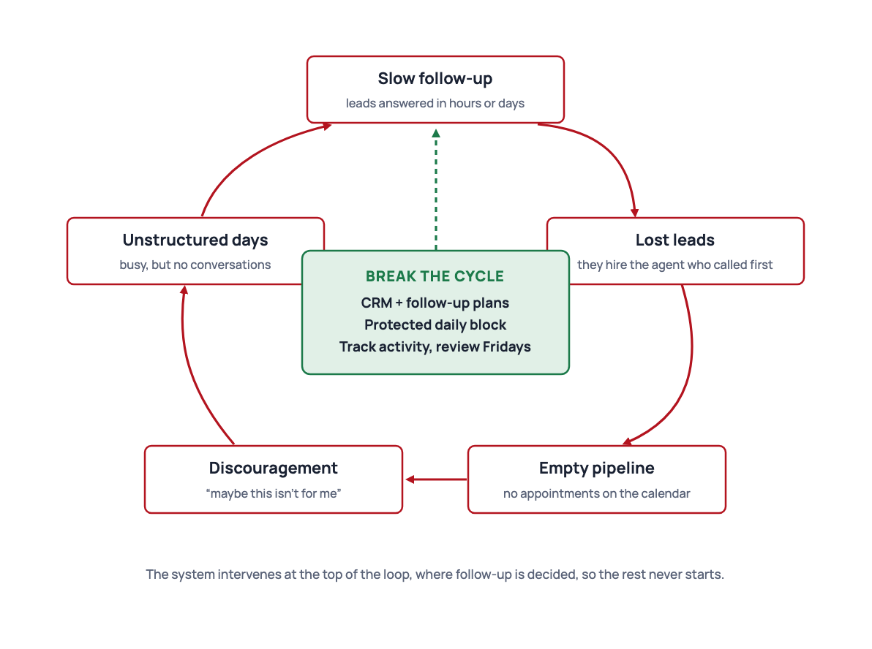
Figure 6. The new-agent pitfall cycle. Each error causes the next. Installing a simple system breaks the loop at its first link.

The one correction
You do not need six fixes. You need one system that makes the six errors hard to commit:
- Install your CRM and follow-up plans. Follow-up becomes automatic and documentation becomes the default.
- Protect a daily prospecting and follow-up block. Structure replaces willpower.
- Track activity, not closings. You can see progress every week, so the 90-day wait is bearable.
- Review every Friday. Small drifts get corrected before they become habits.
Most of these pitfalls disappear within a month of the system being in place. Not because you became a different person, but because the system does the remembering.
● TRY IT TODAY
- Score yourself honestly on each of the six errors from 1 (never) to 5 (every day).
- For your highest score, read the chapter named in the Fix column and do its exercise this week.
- Ask your office productivity coach or a mentor to score you too. Compare.

● CHECKPOINT
- Which of the six errors are you most prone to, and what does it cost?
- In what order do the errors feed each other?
- What are the four parts of the one correction?

KEY TAKEAWAYS
- The six errors are predictable and linked. One starts the loop; the loop runs on its own.
- You do not need willpower. You need a system that makes the errors hard to commit.
- Your CRM, a protected block, activity tracking and a Friday review break the cycle.
CHAPTER 8

8 Staying organized and motivated
Organization reduces stress, and lower stress protects motivation. Both come from the same place: one source of truth and a calendar that is already decided.
IN THIS CHAPTER YOU WILL LEARN TO
- Time-block a week so that lead generation happens before anything else.
- Use a daily structure that opens and closes in your CRM.
- Protect motivation by measuring leading indicators and reviewing every Friday.

One source of truth
Every contact, note, task and opportunity lives in your CRM. Not some of them. Not the important ones. All of them. The moment you keep a second list, you have two places to check and one of them will be wrong. If a conversation happened and it is not in your CRM, treat it as not having happened: log it now.

A sample day
- Morning (first 2 to 3 hours). Review the CRM dashboard. Clear overnight follow-up plan tasks. Make follow-up calls, then prospecting calls, until you hit your daily conversation number.
- Midday. Appointments, showings, listing previews, or more prospecting if the calendar is empty.
- Afternoon. Client work: offers, listing preparation, marketing, additional follow-up.
- End of day (15 minutes). Update your CRM. Move Opportunities. Write tomorrow's top three priorities.
The morning block is sacred because it is the only time of day that nobody else wants. Clients, lenders and inspectors will all ask for afternoons. Give them afternoons.

Time-blocking the week
 | MON | TUE | WED | THU | FRI
8:00 | CRM dashboard, plan the day
8:30 | Follow-up plan tasks
9:30 | Prospecting (sphere, open-house follow-ups, farm) |  |  |  | Prospecting, then pipeline review
11:30 | Lunch, errands, email
13:00 | Appointments | Appointments | Content batch, marketing | Appointments | Appointments
16:00 | Client work, transaction tasks
17:30 | End-of-day CRM update, top three for tomorrow

Table 8.1. A sample weekly time block. Lead generation sits in the same place every day so it never depends on how you feel.
● FIELD NOTE
Protect the block by telling people about it. "I'm with clients until 11:30, can we talk at 1?" is true, and it trains your sphere, your lender and your family to expect it.

Weekly activity targets
These are the numbers a full-time new agent should aim for each week while also handling client work and learning. Start at the lower end of each range in your first 30 days while the habit and the system settle in, then raise them as your confidence grows.
ACTIVITY | WEEKLY TARGET | NOTES AND PURPOSE
Outbound calls | 40 to 60 | Mix of sphere, database and new leads. Focus on conversations, not just dials.
Conversations | 15 to 25 | Actual two-way talks, by phone or in person. The leading indicator of future appointments.
Follow-ups completed | 30 to 50 | Follow-up plan tasks, nurture touches and overdue contacts cleared. Consistency here drives conversion.
Appointments set | 3 to 6 | Buyer or seller consultations, listing appointments or showings. Quality over quantity early on.
Open houses or events | 1 | One a week builds local presence and generates new contacts.
Database updates | Daily | Log notes, update stages and clear CRM tasks before ending the day.

Table 8.2. Weekly activity targets for a new agent. Prioritize conversations and follow-ups over raw call volume, and review the numbers every Friday in your CRM to set next week's plan. Appendix A is the fill-in scorecard.

Motivation that lasts
Motivation fails when you measure the wrong thing. If the only scoreboard is closings, you will go 60 to 90 days with a score of zero, and nobody stays motivated through that. Keep a scoreboard of leading indicators instead: calls, conversations, follow-ups completed, appointments set. Those numbers move every day you do the work. Table 8.2 sets the targets and Appendix A is the scorecard.
Three habits protect motivation:
- Celebrate small wins. A booked appointment is a win. Ten conversations before noon is a win. Say it out loud or write it down.
- Review every Friday. Compare this week's numbers to last week's. Decide one thing to do differently. Then stop working on it until Monday.
- Stay close to the office. Training, accountability partners, team meetings. Real estate is a solo business that is easier with company.
● PITFALL
Letting a slow week become a slow month by "waiting for things to pick up". Nothing picks up on its own. Go back to the morning block and the daily number; the market responds to activity.

● TRY IT TODAY
- Build Table 8.1 into your calendar as recurring events for the next 12 weeks.
- Print Appendix A and fill in this week's numbers, even if they are small.
- Find an accountability partner at your office and agree to share numbers every Friday.

● CHECKPOINT
- Where does every contact, note and task live, and what do you do when one is missing?
- Why does lead generation belong in the morning?
- Which leading indicators are on your scorecard, and what is the weekly target for each?

KEY TAKEAWAYS
- Your CRM is the only list. A conversation not logged did not happen.
- Lead generation goes first in the day, in the same place every day.
- Measure leading indicators, celebrate small wins, review on Fridays, stay connected.
PART VI

Serve and keep
A consultation is a conversation. An objection is a request for information. A closed client is the beginning of the relationship, not the end.
CHAPTER 9

9 Working with clients and dealing with objections
A good consultation is a conversation, not a pitch. Ask, listen, then show how you work and why it helps them.
IN THIS CHAPTER YOU WILL LEARN TO
- Run a buyer consultation and a seller consultation in a repeatable sequence.
- Handle objections with curiosity using a four-step pattern.
- Document every conversation so nothing is lost or disputed.

The consultation sequence
Both buyer and seller consultations follow the same shape. Set the frame, ask, listen, present, agree on next steps. Agents who skip the asking and go straight to presenting lose the client's trust before they have earned it.
STEP | BUYER CONSULTATION | SELLER CONSULTATION
1. Frame | The opening script from Chapter 6. Agree on the agenda. | The opening script from Chapter 6. Agree on the agenda.
2. Ask | Timeline, motivation, financing, must-haves, deal-breakers, who else is involved in the decision. | Goals, timeline, why they are moving, what they believe the home is worth, past experience with agents.
3. Listen | Repeat back what you heard. "So the priority is the school district, and a yard matters more than square footage." | Repeat back. "You need to be in the new city by August, and net proceeds matter more than top-line price."
4. Present | How the process works step by step, how you search, how offers work in this market, what representation means. | Comparable sales, your pricing recommendation and the reasoning, your marketing plan (Chapter 3), what happens week by week.
5. Agree | Buyer representation agreement, lender introduction, first showing date. | Listing agreement, price, photography date, go-live date.

Table 9.1. The five-step consultation. Steps 2 and 3 should take at least half the meeting.

Objections are questions in disguise
Most objections are requests for more information or reassurance. "Your commission is too high" usually means "show me what I get for it." "We want to wait" usually means "we are nervous about the market." Respond with curiosity, not defense. The four-step pattern below works for nearly every objection, and Table 9.2 applies it to the ones you will hear most.
- Acknowledge. "That makes sense." You are not agreeing; you are showing you heard.
- Clarify. "Can I ask what's behind that?" Find the real concern.
- Respond. Answer the real concern with facts, a story, or a demonstration.
- Check. "Does that address it?" Then stop talking.
● SCRIPT · "WE WANT TO INTERVIEW OTHER AGENTS."
"I think that's smart; this is a big decision. Can I ask what you'll be comparing? ... Great. Then let me make sure you leave today with those answers from me, so you have a fair comparison. And if you'd like, I'll follow up Thursday after you've met the others."
Purpose: stay in the running and set the follow-up. Next step: a scheduled call after the other interviews.

Objection quick reference
Treat each response as a starting framework, not a line to memorize. After you respond, ask a question that moves the conversation forward. Log the objection and your response in your CRM so the next follow-up is specific. Practice the three or four you hear most until they feel natural.
OBJECTION | RESPONSE FRAMEWORK | GOAL OF THE RESPONSE
"I'm just looking." | Acknowledge and offer value. "That's fine. Would it help if I sent a few options that match what you described, so you can see what's out there?" | Keep the conversation open and useful.
"We're not ready yet." | Explore timeline and stay in touch. "No problem. When do you think you might be ready? I can send occasional updates so you're informed when the time comes." | Qualify timing and earn permission to nurture.
"I already have an agent." | Respect and leave the door open. "Great, I'm glad you have help. If anything changes or you'd like a second opinion, feel free to reach out." | Stay professional and memorable.
"Your commission is too high." | Focus on value and net proceeds. "I understand. Let's look at what you actually net after marketing, negotiation and the sale. Most clients find the difference is worth it." | Shift from fee to outcome.
"I want to wait for the market to improve." | Provide data and options. "That's a common thought. Here's what similar homes have done recently. We can also look at what waiting might cost versus moving now." | Educate without pressure.
"I need to think about it." | Clarify the real concern. "Of course. What specifically would you like to think through? I'm happy to answer any questions that would help." | Uncover the real objection.
"Can you just send me listings?" | Agree and add a next step. "Absolutely. I'll send a few. What's the best way for me to follow up after you've had a chance to look?" | Move from passive to engaged.
"I'm working with another agent on a home." | Stay helpful and low-pressure. "No problem at all. If that one doesn't work out or you'd like another perspective later, I'm here." | Preserve the relationship.
"You're new, aren't you?" | Be honest and specific. "I am, and that means you get my full attention. My office and broker are behind every file I touch. What matters most to you in an agent?" | Replace worry with evidence.
"We want to interview other agents." | Support it and set the follow-up. "That's smart. What will you be comparing? Let me make sure you leave today with those answers from me, and I'll follow up after you've met the others." | Stay in the running with a scheduled next step.

Table 9.2. Objection handling quick reference. The first eight are the objections you will hear most in year one.

Document everything
After every consultation, offer discussion, price change or disclosure conversation, write a short note in your CRM: date, who, what was discussed, what was decided, what happens next. Two minutes of typing protects you from "but you said" months later and makes your follow-up specific. Chapter 11 covers what to document for legal protection.

After the transaction
Stay in touch. The clients who feel cared for after closing become your best source of future business. Chapter 10 shows the post-close plan. The habit starts at the closing table: thank them, ask for the introduction, and tell them to expect to hear from you.
● TRY IT TODAY
- Write your own version of the buyer consultation, step by step, on one page.
- Pick the two objections you fear most in Table 9.2 and practice the four-step response out loud.
- Go back through the last week and add a note in your CRM for every conversation that is missing one.

● CHECKPOINT
- What are the five steps of a consultation, and which two take half the time?
- What are the four steps for handling an objection?
- What goes in a conversation note?

KEY TAKEAWAYS
- Frame, ask, listen, present, agree. Asking and listening come before presenting.
- Objections are requests for information. Acknowledge, clarify, respond, check.
- Document every conversation in your CRM the same day.
CHAPTER 10

10 Keeping clients: long-term relationships
A database of past clients and sphere contacts who hear from you regularly is the most valuable asset you will build. It is also the cheapest one to maintain.
IN THIS CHAPTER YOU WILL LEARN TO
- Put every closed client on a post-close follow-up plan the day of closing.
- Add value in ways that do not feel like marketing.
- Reactivate a database that has gone quiet.

The post-close plan
The average homeowner moves again within seven to ten years and knows several people who will move before then. The agent they remember gets those transactions. Being remembered is a schedule, not an accident.
WHEN | TOUCH | PURPOSE
Closing day | Handwritten note and a small closing gift. | End on a high note. Ask for the introduction.
1 week | Call: "How's the move going? Anything you need?" | Catch problems early. Offer vendor introductions.
30 days | Call or visit. Ask for a review on your Agent Site. | Reviews drive online leads. Second referral ask.
Quarterly | Call with a reason: market update, tax season, seasonal maintenance. | Stay useful. Hear about life changes early.
Home anniversary | Card or call with an updated home value. | The most natural seller conversation you will ever have.
Annually | Client appreciation event or a personal gift. | Make the relationship social, not transactional.

Table 10.1. The post-close plan. Build it once as a follow-up plan and apply it at every closing.

Adding value without selling
The test for every touch: would the person be glad to receive it if they were never going to move again? Local insights, a reminder to change furnace filters, a list of trusted contractors, a note on a property tax deadline, an invitation to a neighborhood event. These pass the test. "Thinking of selling?" every month does not.
- Vendor list. Keep a short list of a plumber, electrician, handyman, painter and cleaner you trust. Introducing them is a gift that costs you nothing.
- Home value updates. Once a year, unprompted. Homeowners love knowing. Sellers come from this.
- Life events. A new baby, a promotion, a graduation. A card beats a market update.

Reactivating a quiet database
If you have let your database go cold, do not apologize for it. Send one useful piece of market information to everyone, then start calling in small batches with a simple "thinking of you" and one question about how things are. Most people will be glad to hear from you. Put everyone you reach back on the quarterly plan so it does not go cold again.
● FIELD NOTE
Track one more number: referrals received per month. When this number grows, your business becomes less dependent on paid leads every year. Agents in their fifth year often get more than half their business this way.

● TRY IT TODAY
- Build the post-close follow-up plan from Table 10.1 in your CRM.
- List five vendors you would recommend without hesitation. Add them to your CRM with a "Vendor" tag.
- Find the next three home anniversaries in your database and schedule the calls.

● CHECKPOINT
- What are the six touches in the post-close plan?
- What is the test for whether a touch adds value?
- How do you reactivate a database that has gone quiet?

KEY TAKEAWAYS
- Every closed client goes on a post-close plan the day of closing.
- Give value they would want even if they never moved again.
- Home anniversaries and value updates are where seller conversations begin.
CHAPTER 11

11 Legal protection and professional standards
Good documentation protects you and your clients. When in doubt, ask your broker or office leadership before you act.
IN THIS CHAPTER YOU WILL LEARN TO
- Provide agency disclosure at the right moment and record that you did.
- Apply Fair Housing rules in marketing and in conversation.
- Keep a documentation habit that would hold up if questioned.

● READ THIS FIRST
This chapter describes professional habits, not legal advice. Agency, disclosure and advertising rules differ by state and change over time. Your broker, your office leadership and your state association are the authorities. When any situation feels unusual, stop and ask before you act.

Agency disclosure
Before you provide services to a buyer or seller, they must understand whom you represent and what that means. Your state has a required disclosure form and a required timing, usually at first substantive contact. Learn both in your first week. Present the form in plain language, answer questions, and keep the signed copy in your transaction system. If a conversation moves from casual to substantive, that is the moment to disclose.

Fair Housing
Federal law prohibits discrimination in housing on the basis of race, color, religion, national origin, sex, familial status and disability. Many states and cities add further protected classes. The rules apply to how you advertise, whom you serve, what you say about neighborhoods and how you treat every inquiry.
- In marketing. Describe the property, not the ideal buyer. "Great for families" and "perfect for young professionals" are both problems. "Four bedrooms, fenced yard, two blocks from the park" is fine.
- In conversation. Do not characterize neighborhoods by who lives there. When a client asks "is this a good area?", point them to objective sources on schools, crime statistics and amenities rather than offering your opinion of the people.
- In service. Give every inquiry the same response time, the same information and the same options. Your speed-to-lead automation helps here because it treats everyone identically.

What to document
Keep notes in your CRM or your transaction system for every item below. Date, parties, what was said or delivered, and what was decided.
- Agency disclosure given and signed, with the date.
- Every offer, counteroffer and the client's instruction on each.
- Pricing conversations and the client's decision.
- Disclosures delivered (property condition, lead paint, HOA documents) and when.
- Inspection findings discussed and the client's choices.
- Any advice you gave that the client declined to follow.
- Referrals to lenders, inspectors or attorneys, with a note that the client chose freely.

Professional standards
- Follow the National Association of REALTORS® Code of Ethics and your local MLS rules.
- Never give legal, tax or structural advice. Refer to the professional.
- Keep client information confidential, including after the transaction.
- Respect do-not-call and anti-spam rules. Honor every opt-out immediately in your CRM.
- Know your office policy on wire fraud warnings, and repeat the warning to every client before closing.
● TRY IT TODAY
- Find your state's agency disclosure form and read it aloud until you can explain it in two sentences.
- Review your last ten social posts and listing descriptions for language that describes people instead of property.
- Ask your broker what three situations they most want to hear about before you act.

● CHECKPOINT
- When must agency disclosure happen in your state?
- Name the seven federally protected classes.
- What do you do when a client asks whether an area is "good"?

KEY TAKEAWAYS
- Disclose agency at first substantive contact and keep the signed copy.
- Describe property, never people. Treat every inquiry identically.
- Document decisions the same day. Ask your broker before anything unusual.
PART VII

Execute
The first 90 days, measured weekly. Everything in this book reduces to a few numbers you can check every Friday.
CHAPTER 12

12 Daily, weekly and monthly execution plans
Ninety days is long enough to build the system and start a pipeline, and short enough to hold yourself to.
IN THIS CHAPTER YOU WILL LEARN TO
- Follow a 90-day roadmap with milestones at days 30, 60 and 90.
- Measure the same four numbers every week.
- Run a monthly review that adjusts where your time goes.

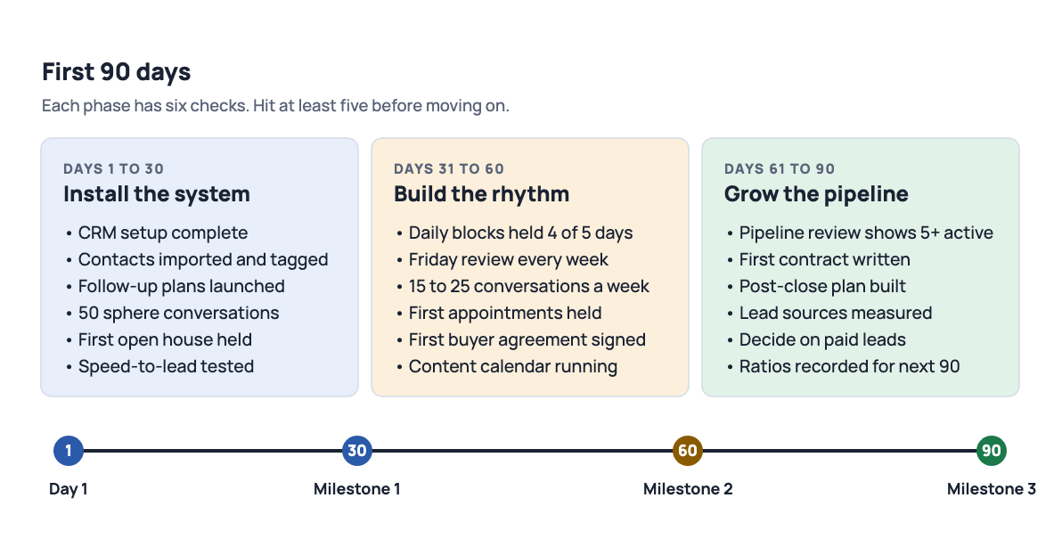
Figure 7. The first 90 days milestone roadmap. Install the system, build the rhythm, then grow the pipeline. Closings usually follow in the second 90 days.

Days 1 to 30: install the system
Finish CRM setup (Chapter 4), import and tag contacts, launch the basic follow-up plans, and have at least 50 real conversations with your sphere. Hold one open house or one networking event. Run the speed-to-lead test. Do not worry about closings; worry about whether the system is on.

Days 31 to 60: build the rhythm
Hold the morning block at least four days out of five. Hit 15 to 25 conversations a week and 3 to 6 appointments set (Table 8.2). Review your numbers every Friday. By day 60 you should have held your first consultations and signed your first buyer representation agreement. The content calendar from Chapter 3 should be running on its own.

Days 61 to 90: grow the pipeline
Your pipeline review should show at least five active opportunities. Write your first contract. Build the post-close plan before you need it. Count the results by lead source and decide, with data, whether paid leads make sense next quarter. Record your conversion ratios so the next 90 days can be planned from real numbers.

Measure every week
Four numbers, every Friday, written down. Table 8.2 sets the targets and Appendix A is the scorecard.
- Conversations held (two-way, about real estate, with a possible buyer, seller or referrer). Outbound calls are the input; count them too.
- Appointments set (consultations and listing presentations on the calendar).
- Follow-ups completed (follow-up plan tasks cleared on time).
- Pipeline value (sum of likely commission across active Opportunities).

Review every month
On the first working day of the month, spend one hour on four questions: Which source produced the most appointments per hour spent? Which follow-up plan got the most replies? Where did leads stall in the pipeline? What one change will I make this month? Write the answers in your CRM as a note to yourself so next month's review can check them.
● TRY IT TODAY
- Write today's date beside "Day 1" and the three milestone dates on Figure 7.
- Put the Friday scorecard review and the monthly review into your calendar for the next 90 days.
- Tell your office productivity coach or team leader your milestone dates and ask them to check in.

● CHECKPOINT
- What must be true by day 30, day 60 and day 90?
- What four numbers go on the weekly scorecard?
- What four questions does the monthly review answer?

KEY TAKEAWAYS
- Install, build rhythm, grow pipeline. Thirty days each.
- Four weekly numbers: conversations, appointments, follow-ups, pipeline value.
- One monthly review decides where your time goes next.
CHAPTER 13

13 Resources and next steps
This handbook is a starting point. Implement one section at a time, measure the results, and refine. Consistency with a simple system outperforms occasional brilliance.

Do these this week
- Log in to your CRM and complete the guided setup.
- Download the CRM mobile app and turn on new-lead notifications.
- Ask your office for follow-up plan recommendations and the local training calendar.
- Put the Friday scorecard review in your calendar for the next 12 weeks.
- Pick one chapter, do its exercise, and move to the next.

Where to get help
- Your office. Team leader, productivity coach, and the agents who are two years ahead of you. Ask for a mentor.
- Brokerage training. The ongoing classes at your office cover scripts, your CRM and lead generation in depth.
- Your broker. For anything legal, contractual or unusual. Before, not after.
- Your lender partners. A good lender teaches you financing and sends you referrals. Meet three and pick one.

The two habits that matter most
If you remember nothing else from this handbook, remember these two. Speed-to-lead: respond in minutes, not hours. Multi-touch follow-up: stay in touch for 90 days and then forever. These two habits separate agents who grow from agents who stay stuck. Everything else in the book exists to make them easy.
THE WHOLE HANDBOOK ON ONE CARD
- Measure activity, not closings. Three or four real conversations a day.
- Work your sphere first. Buy leads only when the system can catch them.
- Your CRM is the only list. Open it first, update it last.
- Respond to new leads in minutes. Then follow up 8 to 12 times over 90 days.
- Ask, listen, present, agree. Objections are questions.
- Every closed client goes on a post-close plan the day of closing.
- Review every Friday. Fix one thing a month. Ask your broker before anything unusual.
APPENDICES

Tools to print and use
A fill-in scorecard, day-by-day starter follow-up plans, a setup checklist and a glossary.
APPENDIX A

A Weekly activity scorecard
Fill it in every Friday. Targets match Table 8.2 and assume a full-time new agent in the first 90 days. Start at the low end of each range for the first 30 days, then raise them from your own ratios.
LEADING INDICATOR | WEEKLY TARGET | WK 1 | WK 2 | WK 3 | WK 4
Outbound calls (sphere, database, new leads) | 40 to 60
Conversations (two-way, phone or in person) | 15 to 25
Follow-ups completed (follow-up plan tasks, nurture touches, overdue contacts) | 30 to 50
Appointments set (consultations, listing appointments, showings) | 3 to 6
Appointments held | 2+
Open houses or events | 1
Database updated before end of day (days out of 5) | 5
New contacts added to your CRM (with source) | 15
Content posted (per Table 3.1) | 2
Morning blocks held (out of 5) | 4+
Active opportunities in pipeline | Growing
Pipeline value (likely commission) | Growing
Referrals received | Track

Table A.1. Weekly scorecard. One change to make next week: ______________________
APPENDIX B

B Follow-up plan starter kit
Four plans to build into your CRM in one afternoon. Write every message in your own voice before you turn the plan on.

B.1 New online lead (90 days)
DAY | TOUCH | CHANNEL | CONTENT
0 | 1 | Text + email (automated) | Thanks for the inquiry about [property]. One easy question.
0 | 2 | Call (you) | Speed-to-lead script. Leave a short voicemail if no answer.
1 | 3 | Email | Three similar homes and an offer to set up a search.
3 | 4 | Text | "Did any of those catch your eye?"
7 | 5 | Call | Qualify: timeline, motivation, financing, representation.
10 | 6 | Email | Value piece: buyer guide or neighborhood report.
14 | 7 | Text | Market note with one number.
21 | 8 | Call | Check in; offer a consultation.
30 | 9 | Email | Monthly market update.
45 | 10 | Text | New listing or price change that fits their search.
60 | 11 | Call | "Where are things at for you?"
75 | 12 | Email | Value piece: case study of a recent client.
90 | 13 | Call | Final check-in, then move to the quarterly database plan.

B.2 New sphere contact: 8x8 (8 weeks)
WEEK | TOUCH | CONTENT
1 | Personal call or visit | Announce you are in real estate. Ask how they are. No pitch.
2 | Handwritten note | "Great to catch up." Business card enclosed.
3 | Email | Neighborhood market snapshot.
4 | Text | A local event or something personal to them.
5 | Mail | Home maintenance checklist for the season.
6 | Call | The referral ask from Chapter 6.
7 | Email | Introduction to a trusted vendor.
8 | Call or coffee | Check in; move to the quarterly plan.

B.3 Quarterly database plan (ongoing)
MONTH | TOUCH | CONTENT
1 | Call | Quarterly call with a reason: market, season, tax deadline.
2 | Email | Market update with three numbers.
3 | Mail or text | Something useful or personal; no ask.
Repeat every quarter. Add a home anniversary touch and a holiday card annually.

B.4 Post-close plan (first year)
Use Table 10.1 in Chapter 10. Closing day, one week, 30 days, quarterly, home anniversary, annual appreciation. After the first year, the contact stays on the quarterly plan.
APPENDIX C

C CRM setup checklist
Finish every item in your first week. Ask your office technology trainer for help with anything that takes more than 30 minutes.

Profile
- Professional headshot uploaded.
- Bio written in plain language (three short paragraphs).
- Phone, email, license number and social links current.
- Marketing Profile complete: colors, logo, tagline.
- Agent Site reviewed on phone and desktop.

Contacts
- Phone contacts exported and imported.
- Email contacts imported.
- Social connections added.
- Duplicates merged.
- Every contact tagged by relationship (sphere, past client, lead, vendor).
- Every contact tagged by lead source.

Follow-up plans
- New online lead plan built (Appendix B.1), with day-0 automated text and email.
- 8x8 sphere plan built (B.2).
- Quarterly database plan built (B.3) and applied to the whole database.
- Post-close plan built (B.4).
- Every message rewritten in your own voice.

Pipeline and routing
- Opportunities stages renamed to match how you work.
- Existing leads placed in the correct stage.
- Lead routing rules set (teams only).

Mobile and testing
- CRM mobile app installed.
- Notifications on for new leads and due tasks.
- Speed-to-lead test completed (friend submits inquiry at 8 p.m.; times recorded).
- Friday review block and monthly review on the calendar.
APPENDIX D

D Glossary
8x8
A follow-up plan of eight touches over eight weeks, used to establish a new relationship with a sphere contact.
Agency disclosure
The required explanation, usually on a state form, of whom the agent represents in a transaction and what that means for the client.
Client App
The consumer app, branded to you, that clients use to search for homes.
Conversation
In this handbook, a two-way exchange about real estate with someone who could buy, sell or refer. Voicemails and unanswered texts do not count.
Cost per closed deal
Money and time spent on a lead source divided by the closings it produced. The number that decides where your budget goes.
CRM
The agent platform for contacts, tasks, follow-up plans, Opportunities, marketing and transactions. Accessed on the web and through the mobile app.
Expired listing
A property whose listing agreement ended without a sale. Owners are often still motivated to sell.
Fair Housing
Federal, state and local laws that prohibit discrimination in housing on the basis of protected characteristics.
Farming
Concentrated, consistent marketing to one geographic neighborhood with the goal of becoming its recognized agent.
Follow-up plan
An automated sequence of touches in your CRM: texts, emails, and tasks that remind you to call.
FSBO
For sale by owner. A property the owner is attempting to sell without an agent.
IDX
Internet Data Exchange. The feed that lets your website display MLS listings and capture search leads.
Lagging indicator
A result that reports what already happened, such as closings or income.
Lead routing
Rules in your CRM that decide which team member receives a new lead.
Leading indicator
An activity you control today that predicts future results, such as conversations and appointments.
Nurture
The scheduled, multi-touch follow-up that keeps a lead engaged until they are ready to act.
Office
A brokerage office. Home of your team leader, productivity coach, training and accountability.
Opportunities
The pipeline in your CRM where each potential transaction moves through stages from new to closed.
Pipeline value
The sum of likely commission across active Opportunities. A weekly scorecard number.
Speed-to-lead
The time between a lead's inquiry and your first real response. Minutes win; hours lose.
Sphere of influence
Everyone who already knows you and would take your call. Your highest-converting lead source.
Touch
Any scheduled contact with a lead or client: call, text, email, note, visit or value piece.
Value piece
A touch that gives something useful (a report, a guide, an introduction) rather than asking for something.
Finding, Keeping, and Nurturing Clients: a practical guide for new agents. Figures 1 to 5 supplied by the author; Figures 6 and 7 drawn for this edition. Conversion figures are typical industry ranges and will vary by market. Nothing here is legal advice; consult your broker.

